HTML/CSS Assignment

Akanksha Tyagi

Id-4701

JVM Trainee

1. **How are inline and block elements different from each other?**

**Block element**-

* It always starts on a new line.
* It always takes up the full width available.
* It has a top and bottom margin.

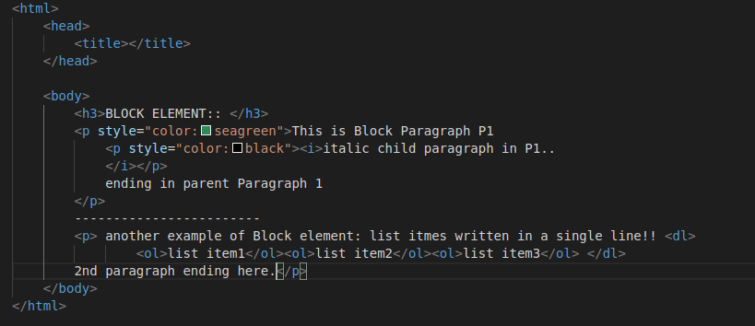

Output: 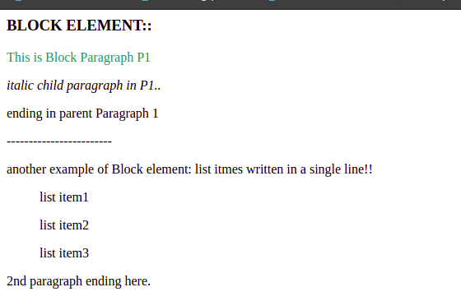

**Inline Element**

* An inline element does not start on a new line.
* An inline element only takes up as much width as necessary.

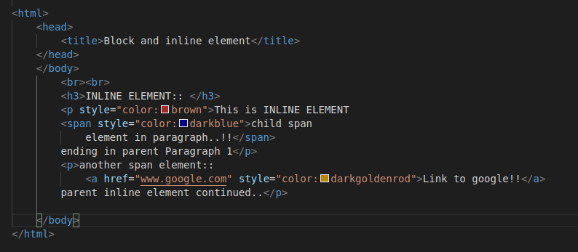

Output: 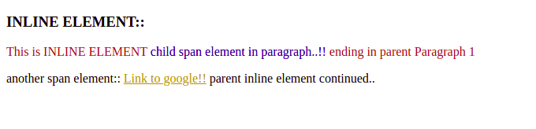

1. **Explain the difference between visibility:hidden and display:none.**

**visibility:hidden** means the tag is not visible, but space is allocated for it on the page. The tag is rendered, it just isn't seen on the page.

**display:none** means that the tag will not appear on the page at all. There will be no space allocated for it between the other tags.

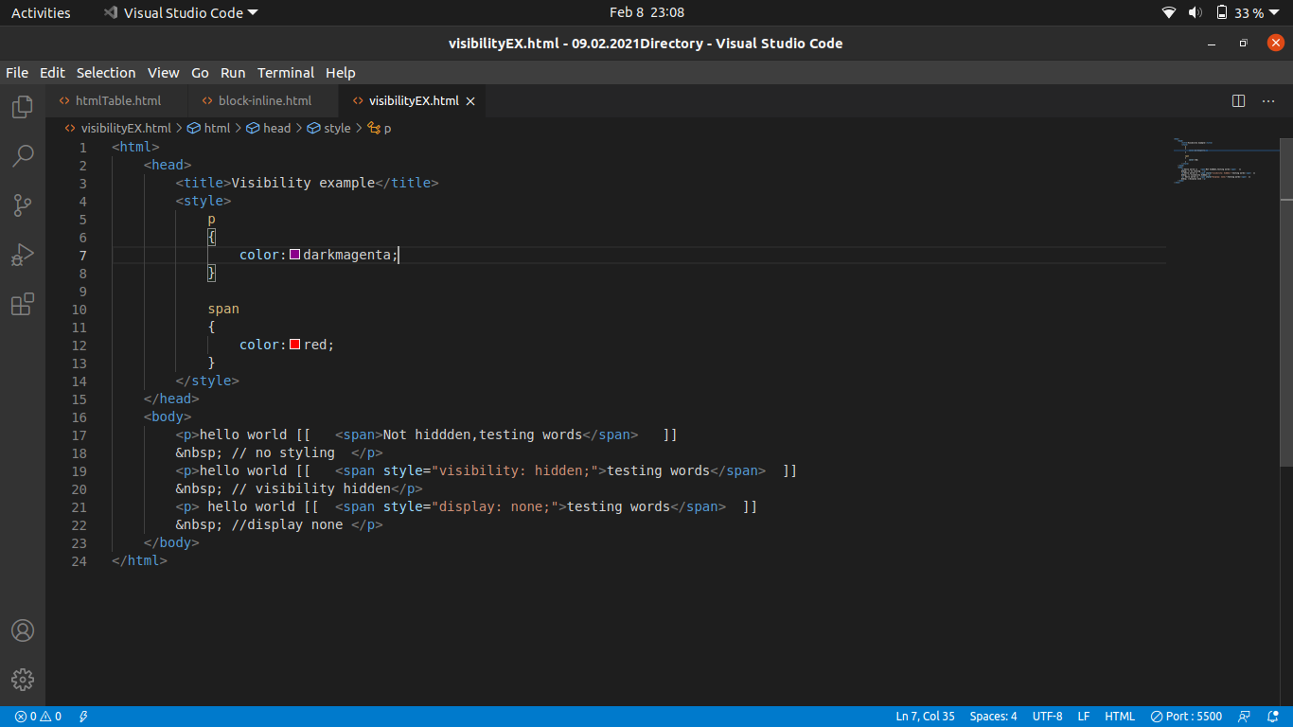

Output: --

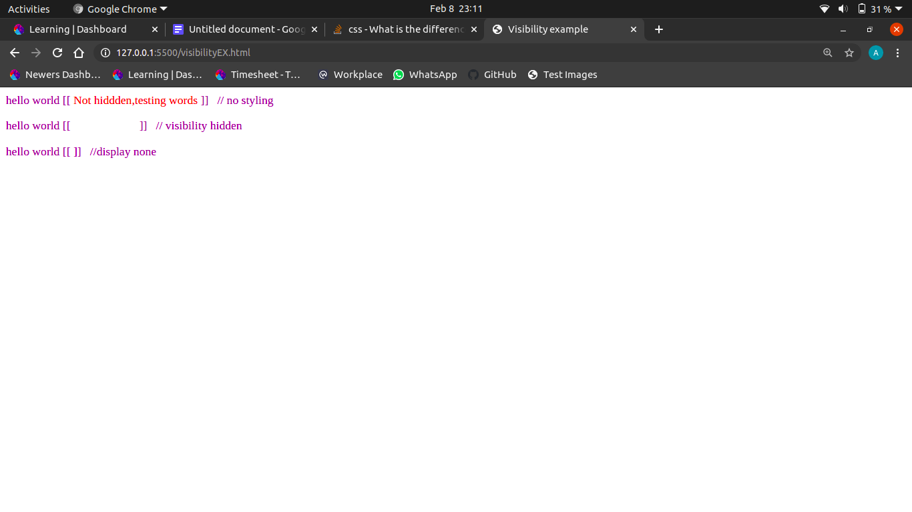

1. **Explain the clear and float properties.**

The float property is used for positioning and formatting contents.

For eg: float:left // aligns the elements to the left of its parent.

Float:right // aligns the elements to the right.

Clear is used to clear the overlapping or rendering of the elements caused by the float: left and float:right.

1. **explain the difference between absolute, relative,fixed and static.**

**position:static**

* It is the default value.
* Static positioned elements are not affected by the top, bottom, left, and right properties.
* An element with position: static; is not positioned in any special way; it is always positioned according to the normal flow of the page.

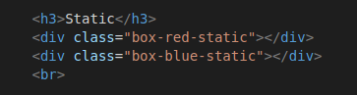

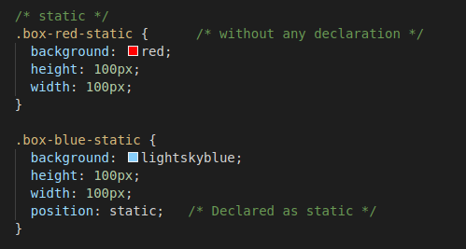

Output:

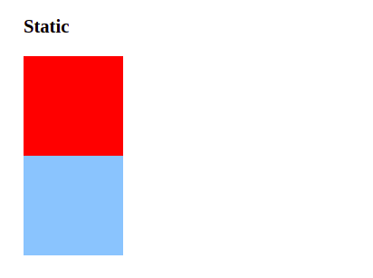

**Position: relative**

* is positioned relative to its normal position.
* We can set these properties such as top,bottom,left,right of a relatively-positioned element. It will adjust away from its normal position. Other elements/contents will not be adjusted because of this.

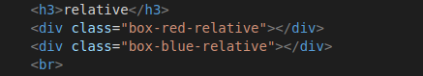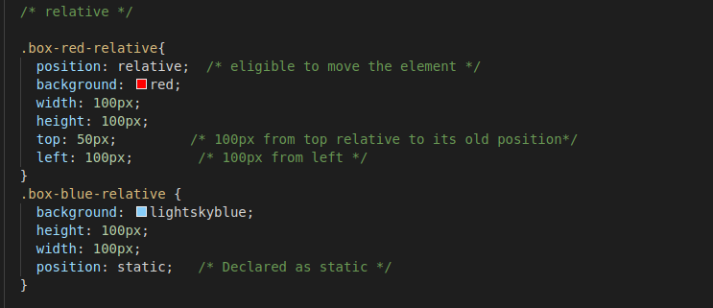

Output: 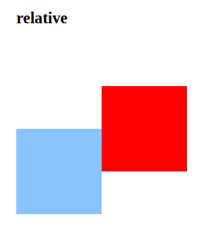

**Position: fixed**

* It is positioned relative to the viewport, which means it always stays in the same place even if the page is scrolled.
* The top, right, bottom, and left properties are used to position the element.
* They are only relative to the <html> document, not any other parents
* They are not affected by scrolling.

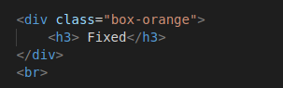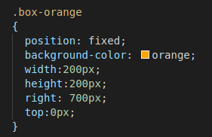

Output:

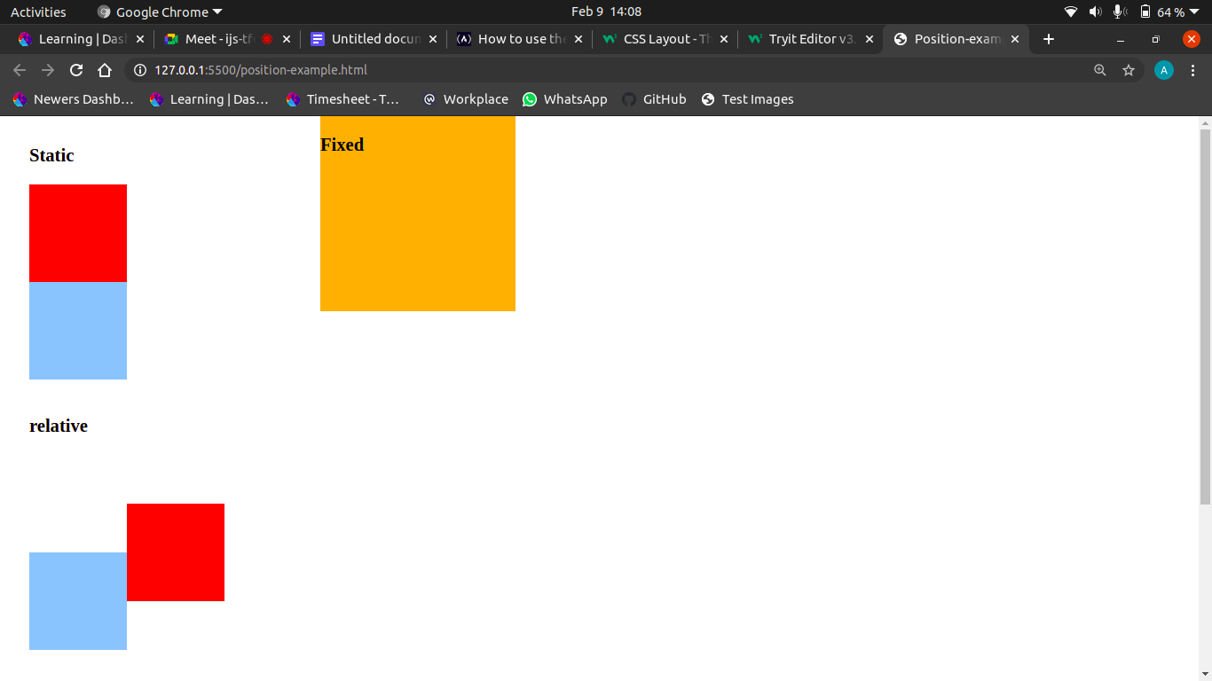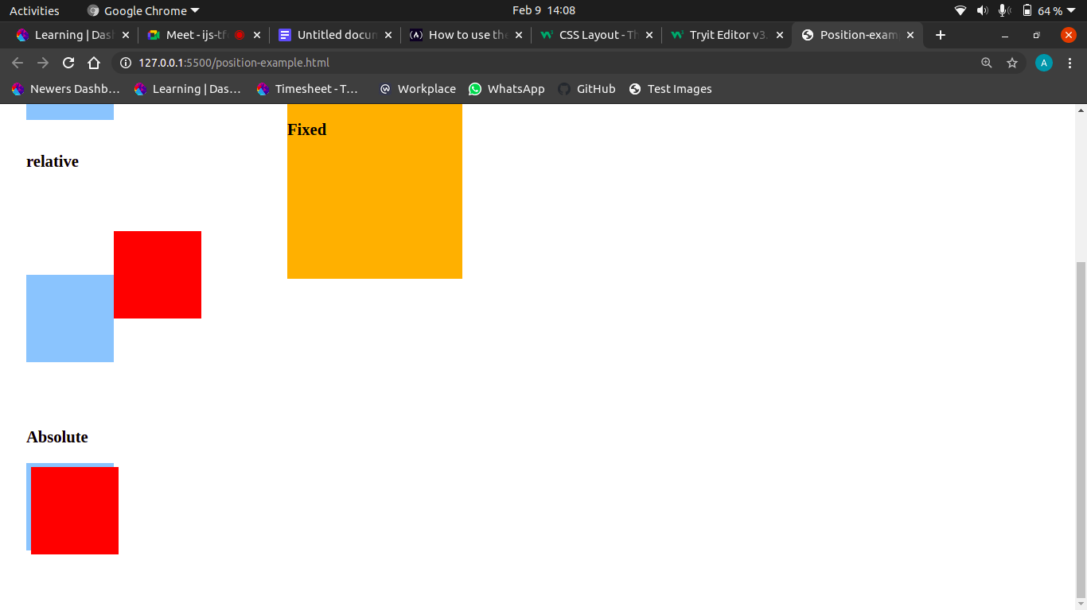

**Position: absolute**

* An element with position: absolute is removed from the normal document flow. It is positioned automatically to the starting point (top-left corner) of its parent element.
* Since it removes the element from the document flow, other elements are affectedand behave as the element is removed completely from the webpage.

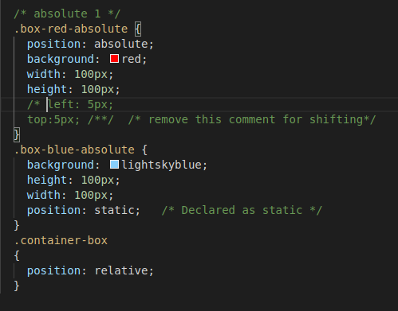

Output:

1. 2.

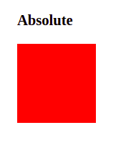 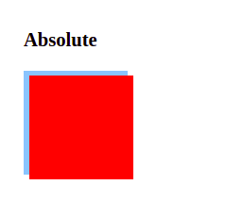// after removing the comments on left and top in “box-red-absolute” css class.

**5. Write the HTML code to create a table in which there are 4 columns( ID , Employee Name, Designation, Department) and at least 6 rows. Also do some styling too.**

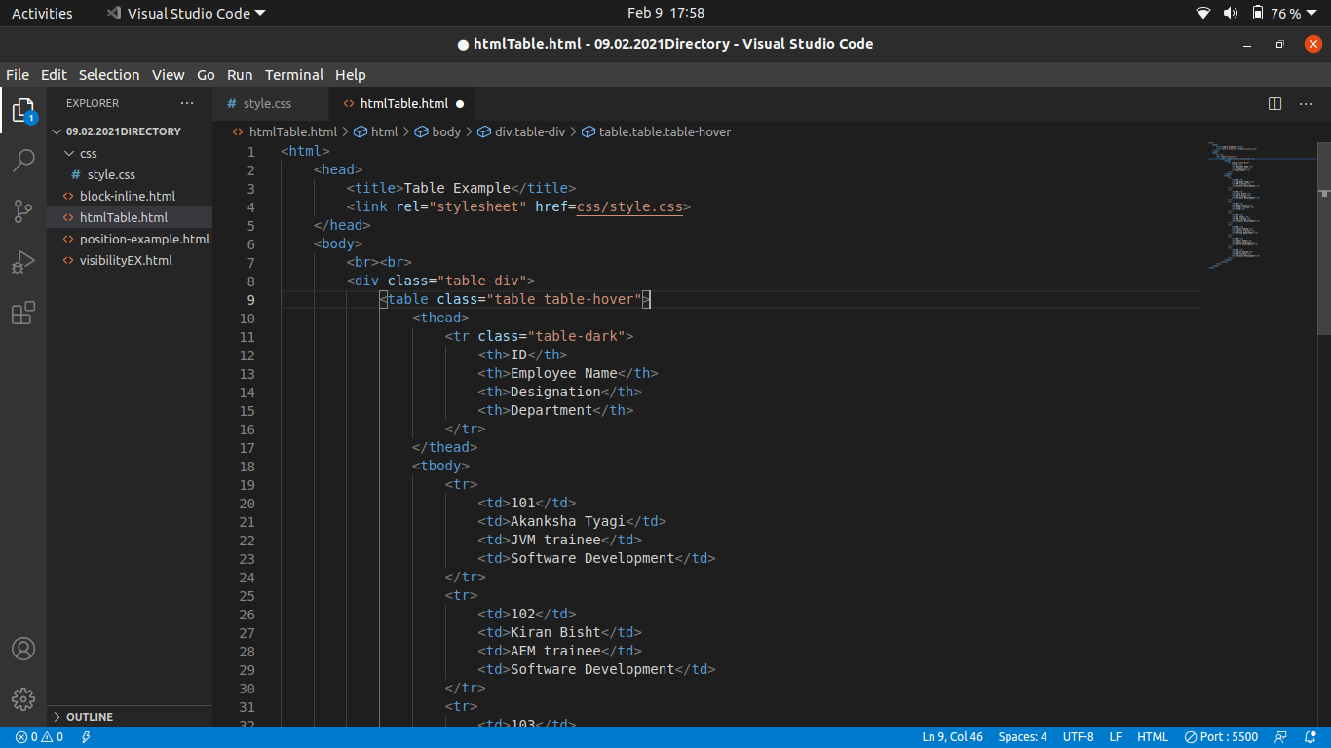

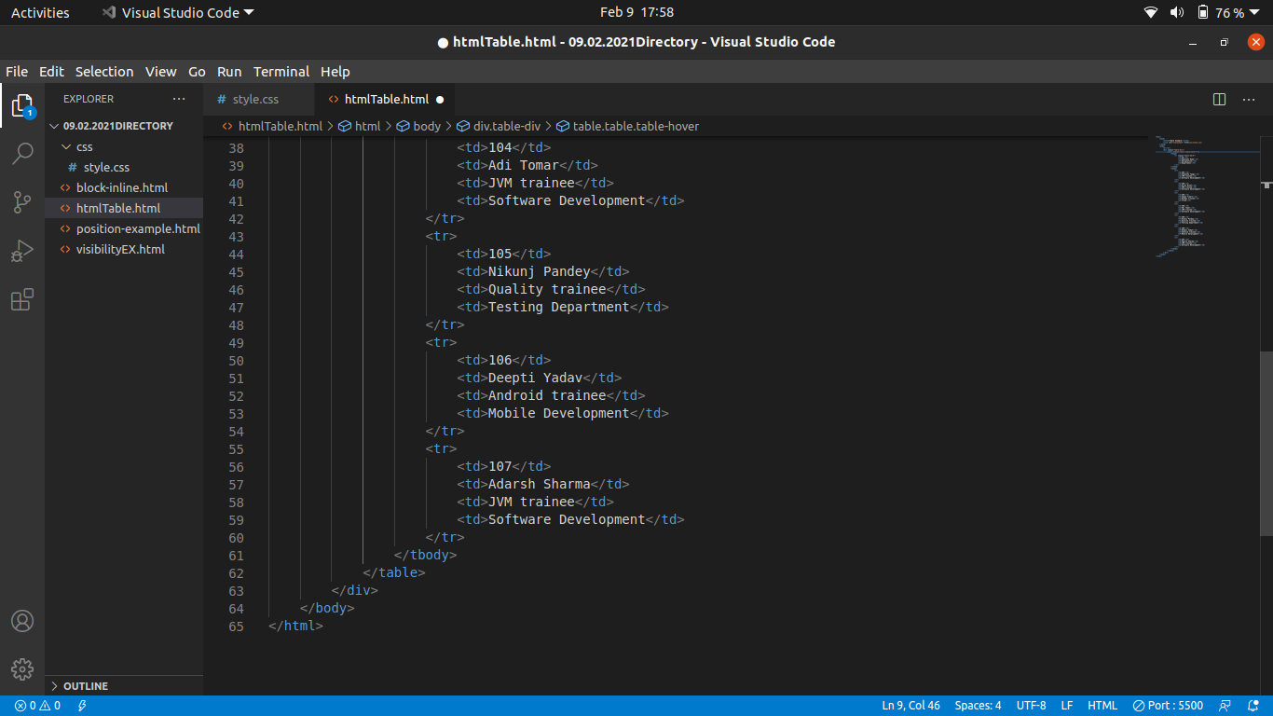

Style.css file

1. 2.

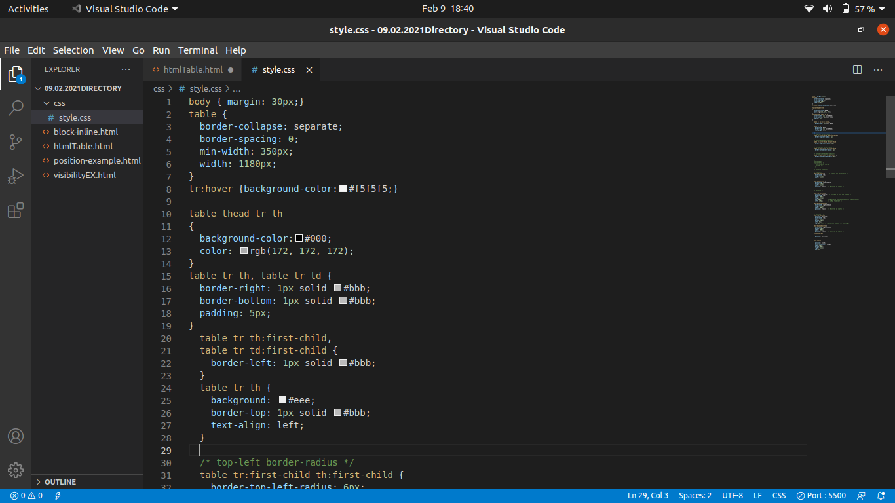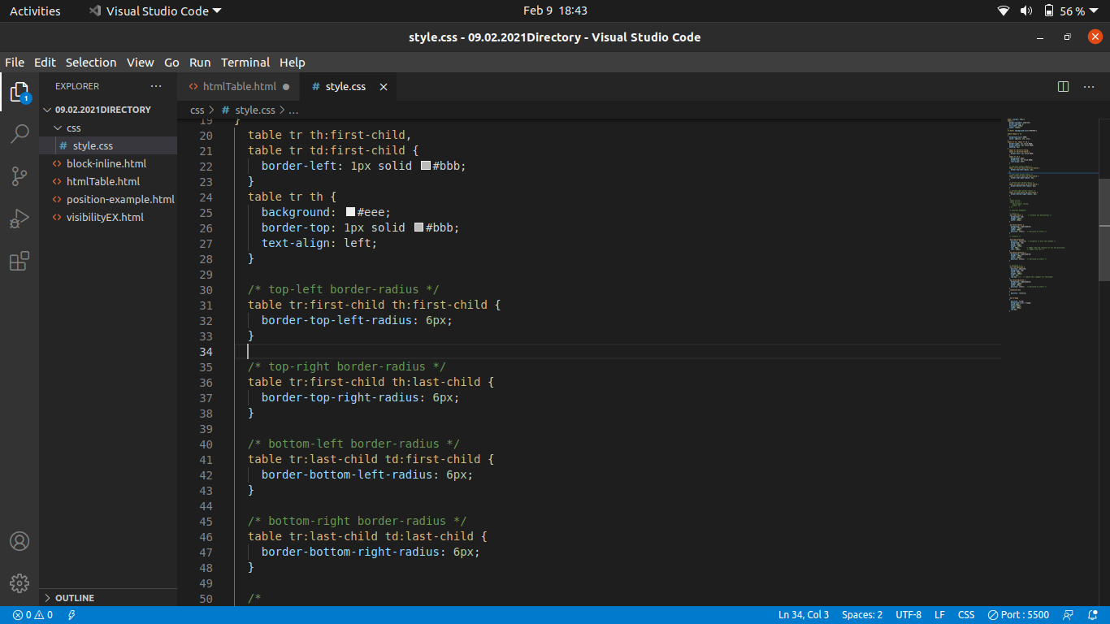 3. 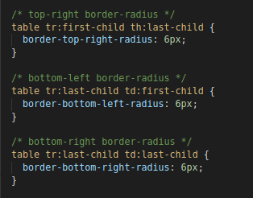

Output:

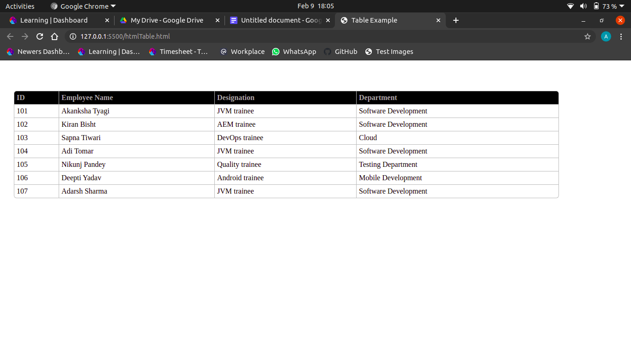

**6. Why do we use meta tags?**

* It defines metadata about an HTML document. Metadata is data (information) about data.
* Meta tags are typically used to specify character set, page description, keywords, author of the document, and viewport settings.
* Metadata is used by browsers (how to display content or reload page), search engines (keywords), and other web services.

**7. Explain Box Model**

In CSS, all the styling and layout of the HTML elements are termed as BOX MODEL.



* **Content** - The content of the box, where text and images appear
* **Padding** - Clears an area around the content. The padding is transparent
* **Border** - A border that goes around the padding and content
* **Margin** - Clears an area outside the border. The margin is transparent.

The box model allows us to add a border around elements, and to define space between elements.

**8. What are the different types of CSS selectors ?**

**CSS selectors** are used to select the content you want to style. Selectors are part of the CSS rule set. CSS selectors select HTML elements according to its id, class, type,

attribute etc.

There are several different types of selectors in CSS.

* CSS element selector
* CSS class Selector
* CSS id selector

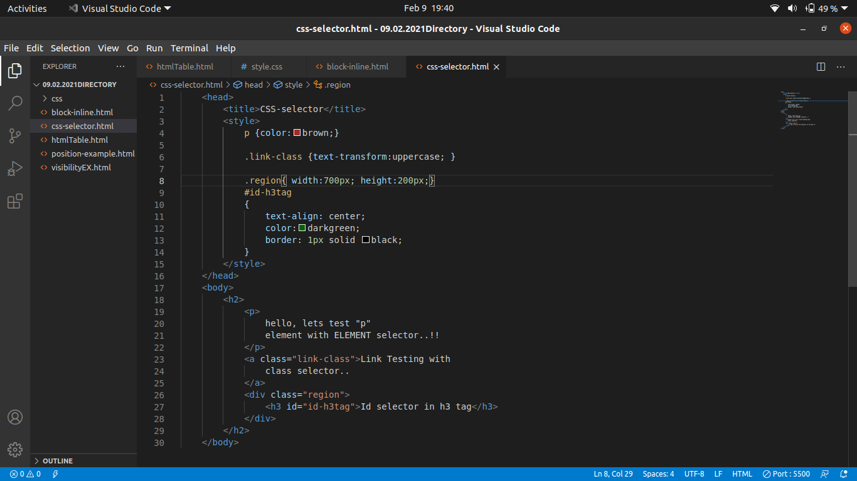

Output: 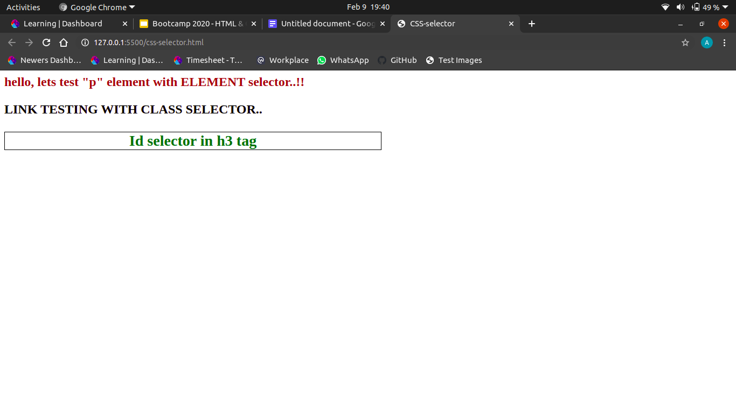

**9. Define Doctype**

A doctype is an instruction that tells the web browser about the markup language in which the current page is written. The Doctype is not an element or tag, it lets the browser know about the version of or standard of HTML or any other markup language(XML ,SGML) that is being used in the document.

< !DOCTYPE html >

**10. Explain 5 HTML5 semantic tags.**

Semantic tags are self explanatory tags. It clearly describes its meaning to both the browser and the developer.

Examples of semantic elements: **<footer>, <section>, <aside>, <header>and <article>** - Clearly defines its content.

i. **<header>**: element represents a container for introductory content or a set of navigational links. A <header> element typically contains:

* one or more heading elements (<h1> - <h6>)
* logo or icon
* authorship information

ii. **<article>**: The <article> element specifies independent, self-contained content. An article should make sense on its own, and it should be possible to distribute it independently from the rest of the web site.

Examples of where an <article> element can be used:

* Forum post
* Blog post
* Newspaper article

iii. **<footer>:** The <footer> element defines a footer for a document or section. A <footer> element typically contains:

* authorship information
* copyright information
* contact information
* sitemap
* back to top links
* related documents

You can have several <footer> elements in one document.

iv. **<aside>:** defines some content aside from the content it is placed in (like a sidebar). The <aside> content should be indirectly related to the surrounding content.

v. **<section>**: <section> element represents a standalone section — which doesn't have a more specific semantic element to represent it — contained within an HTML document. Typically, but not always, sections have a heading. A web page could normally be split into sections for introduction, content, and contact information.